Multiple Sclerosis Patients Successfully Replace Damaged Cells With New Healthy Stem Cells; First Treatment With Placenta

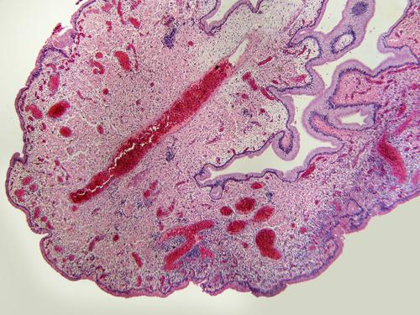

Multiple sclerosis is a chronic, life-altering incurable disease, but an unprecedented treatment may have opened doors up for a successful treatment using cells from human placenta tissues. Researchers from Mount Sinai designed the treatment and have found patients were able to handle the treatment, and published their results in the journal Multiple Sclerosis and Related Disorders.
"This is the first time placenta-derived cells have been tested as a possible therapy for multiple sclerosis," the study’s lead author Fred Lublin, Director of the Corinne Goldsmith Dickinson Center for Multiple Sclerosis, said in a press release. "The next step will be to study larger numbers of MS patients to assess efficacy of the cells, but we could be looking at a new frontier in treatment for the disease."
When a patient is diagnosed with MS, an autoimmune disease that causes the body’s immune system to attack itself and disrupt the flow of information between the brain and the rest of the body, according to the National Multiple Sclerosis Society. More than 2.3 million please are affected by MS and while symptoms are unpredictable and can vary greatly in severity from one person to another, it always worsens overtime. The damaged nerve cells were repaired and tolerated by the MS person’s body successfully with PDA-001, a group of cultured placenta cells that resemble the connective tissue found in bone marrow. A placenta is a organ that encases the fetus inside a pregnant woman's womb, rich in oxygen and nutritents. By using cells cultured from placentas, researchers were able to extract significantly more of these cell-repairing cells from one donor, so they could supply many patients at a time.
Researchers examined the treatment in 16 patients with MS, some had relapsing-remitting multiple sclerosis (RRMS) and others had the more evolved version of the chronic and more debilitating condition called secondary progressive multiple sclerosis (SPMS). Patients were between the ages of 18 and 65 and one group was given a high dose of PDA-001, another were given a low dosage, and a third group was given a placebo. While there is always a risk for MS to worsen once the immune system is experimented with in cell transplants, over the six-month treatment the majority of the patients who were treated with PDA-001 had stabilized or showed improvement.
"We're hoping to learn more about how placental stromal cells contribute to myelin repair," Lublin said. "We suspect they either convert to a myelin making cell, or they enhance the environment of the area where the damage is to allow for natural repair. Our long-term goal is to develop strategies to facilitate repair of the damaged nervous system."

